Ga

**FOOTBALL PITCH RESRVATION SYSTEM.**

Asser Ayman section2.

Habiba Alaa section 2.

Rana Hesham section 2.

Mazen Khaled section 4.

* **Aim:**

This project’s aim is to make a system that allows us to reserve football pitches online instead of going to the pitch and reserve it. This will save time and effort. The software enables the user to search by district, time or to book without searching. It also enables to you to return to the main menu. Also it takes the user data to store it.

* **Functions:**

1-Displying functions (1 for all district, 1 for each district, and 1 for each field)

2-Searching functions (include 3 functions to check every field in each district)

3-Booking functions (1 for all districts, 1 for each district, 1 for each field, 1 for players data entry)

* **structures:**

1. Field : it contains field’s ID , capacity , price and audience provided or not
2. District : it contains district’s name , number of fields , it’s type , coverage and the working hours
3. Player : it contains the username , phone number , and address

* The code is divided into 3 subtasks which are searching by districts & fields, searching by time and booking

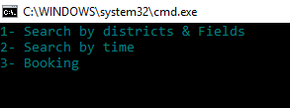.

1. **Searching by districts:** we have 3 districts each contain 4 fields , in this task the software show the user all the districts and its information then the user should choose the desired one

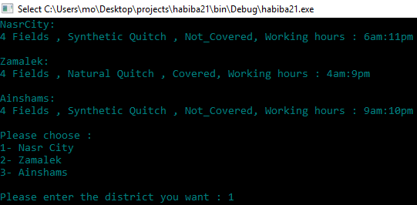

.

When the user choose the district the software will show the fields and its information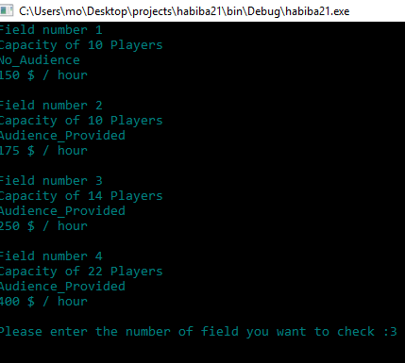

Then the user choose the field and the software will show the available times 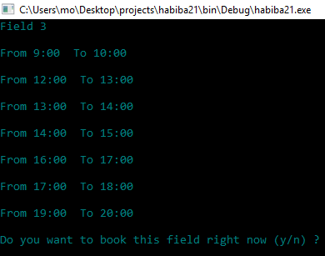

Then the user have the choice to confirm or cancel the reservation if he confirmed it

, he will choose the time then enter his data and it will be saved.

1. **Searching by time:** the user will enter the starting and ending time and the available fields will be shown



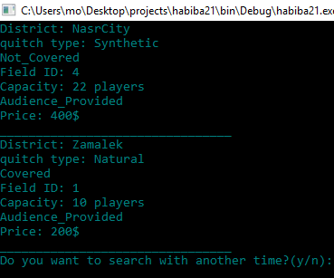.

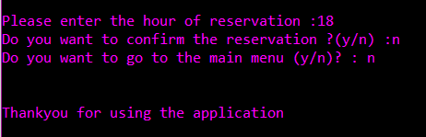**3. Booking:** In this part the user can reserve a pitch directly by choosing the district then choose the field then choose suitable time but without showing any details about the districts and fields the main function of the software in this part is booking. Then the software ask the user to confirm his reservation if the user click yes it will be successful reservation if he click no he will return back to the main menu or exit the program.

Then the user enters the players’ data as shown:

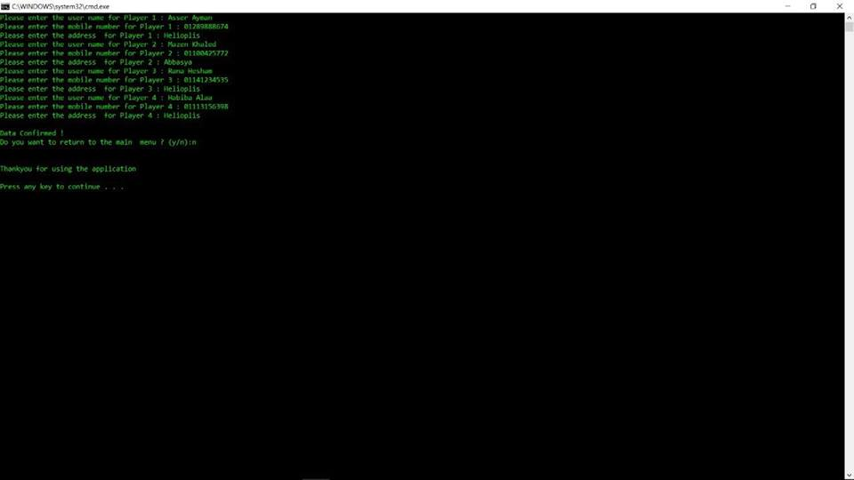

And this data will be saved in a text file.

